1. Change Order numbers to start from TVP2000
2. Change Date and time format
3. Make Ship Date changeable.

* Move to shiping page to change (Cannot change color on Main page unless user clicks the date and goes into the shipping page)

1. Comment Box (Notes) needs to be made so users can “Chat” with each other. Must add user name to enter chat so we know who left a message at what time/date. (must connect with all other pages with comment section)
2. Change Balance to PRINT READY

* Can you explain PRINT ORDER button bellow? (number 1a)

So if we Click that button it would ask us to Print out that page in paper.

* Function to download list custom name/number: (number 1b)
* Using list input of user when order
* Or upload manualy by yourself?
* Just shows list of customers name/ number and sizes.
* Do we keep this page as main detail order page?

Not Main Page. Just new PAge

* Area ( number 2) display what image? (artwork get from order, artwork you uploaded or Proof uploaded) This image will stay the same from artwork from order. Do not change anything. Nothing needs to be done to this.

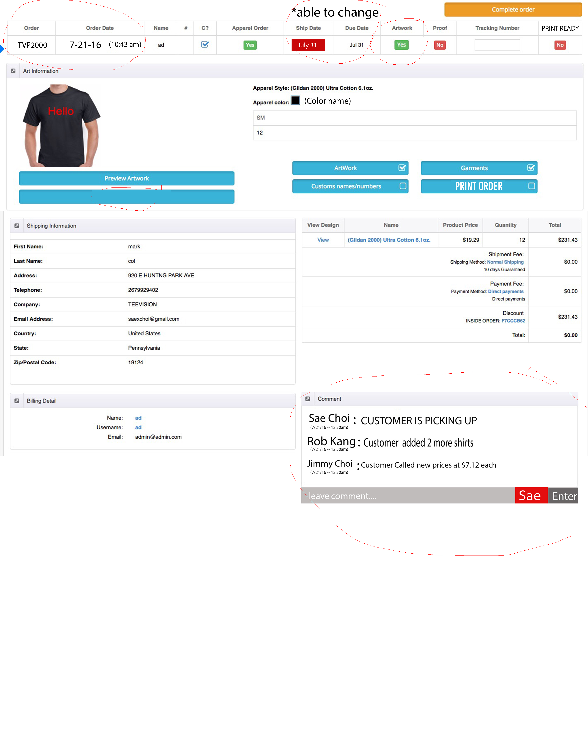

**1a**

**2**

**1b**

APPAREL (Clear)

1. Change order # to Invoice Number (able to add letters and numbers)—remove drop down menu
2. Add “ add Button” to add another invoice number
3. Remove history of different apparel orders. Only THAT one order number should have information about that apparel
4. Add Total of cost of at the end.

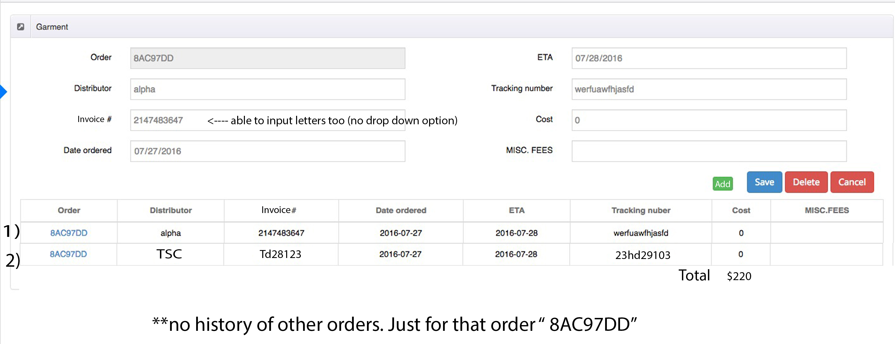

Artwork (THIS IS NEW PAGE)

* Display when click artwork button? Yes to a new page

1. Add information about that orders garments. With name of color shirts
2. Able to manually put in how many colors of front and back
3. When adding file to save user must write name to save so we know who saved it and what time and date.

* I think you no need to write name, Can we use the login name to automaticaly add to? Yes!

1. Comment Section need for this page as well.

* Could you please explain what do delete button do? (number 3) Disregard Delete button. I forgot There is a remove button. We do not need delete button. Sorry!

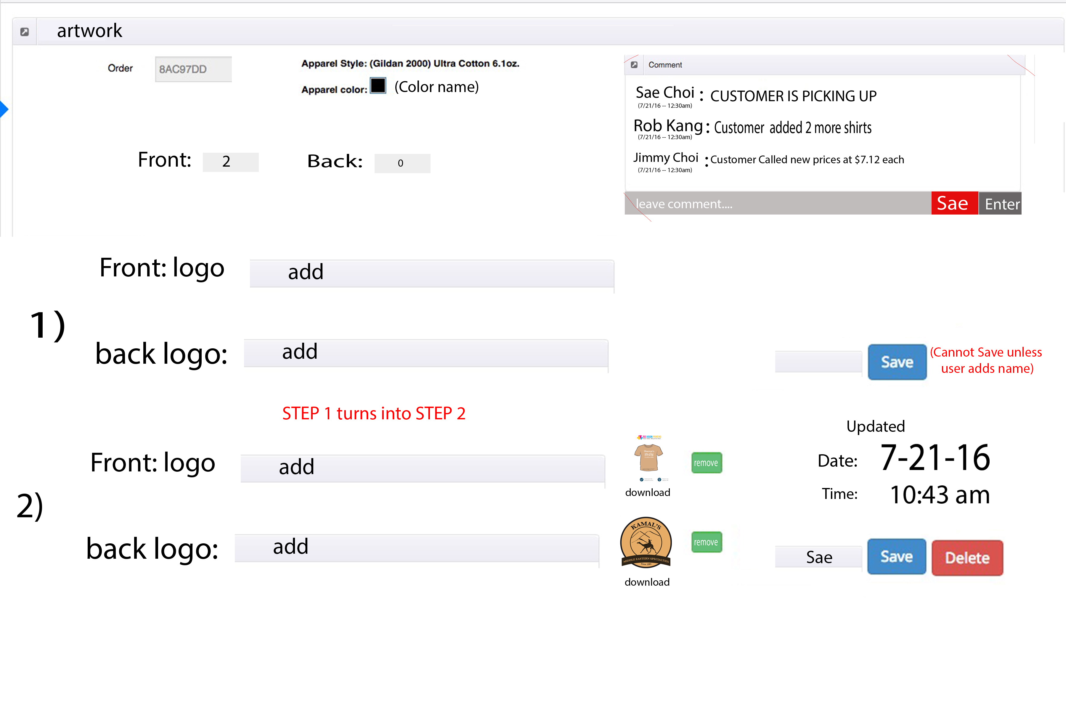

**3**

Proof (THIS IS NEW PAGE)

* Display when click Proof button? Yes

1. *** add comment section
2. add proof with user able to save with name.

* Can we use the login name to automaticaly add to? Yes

1. Add apprve button to change the status of proof button on main change
2. When approved – attached file is copied to PRINT READY PAGE

* Could you please explain what do delete button do?
* Disregard Delete button. I forgot There is a remove button. We do not need delete button. Sorry!

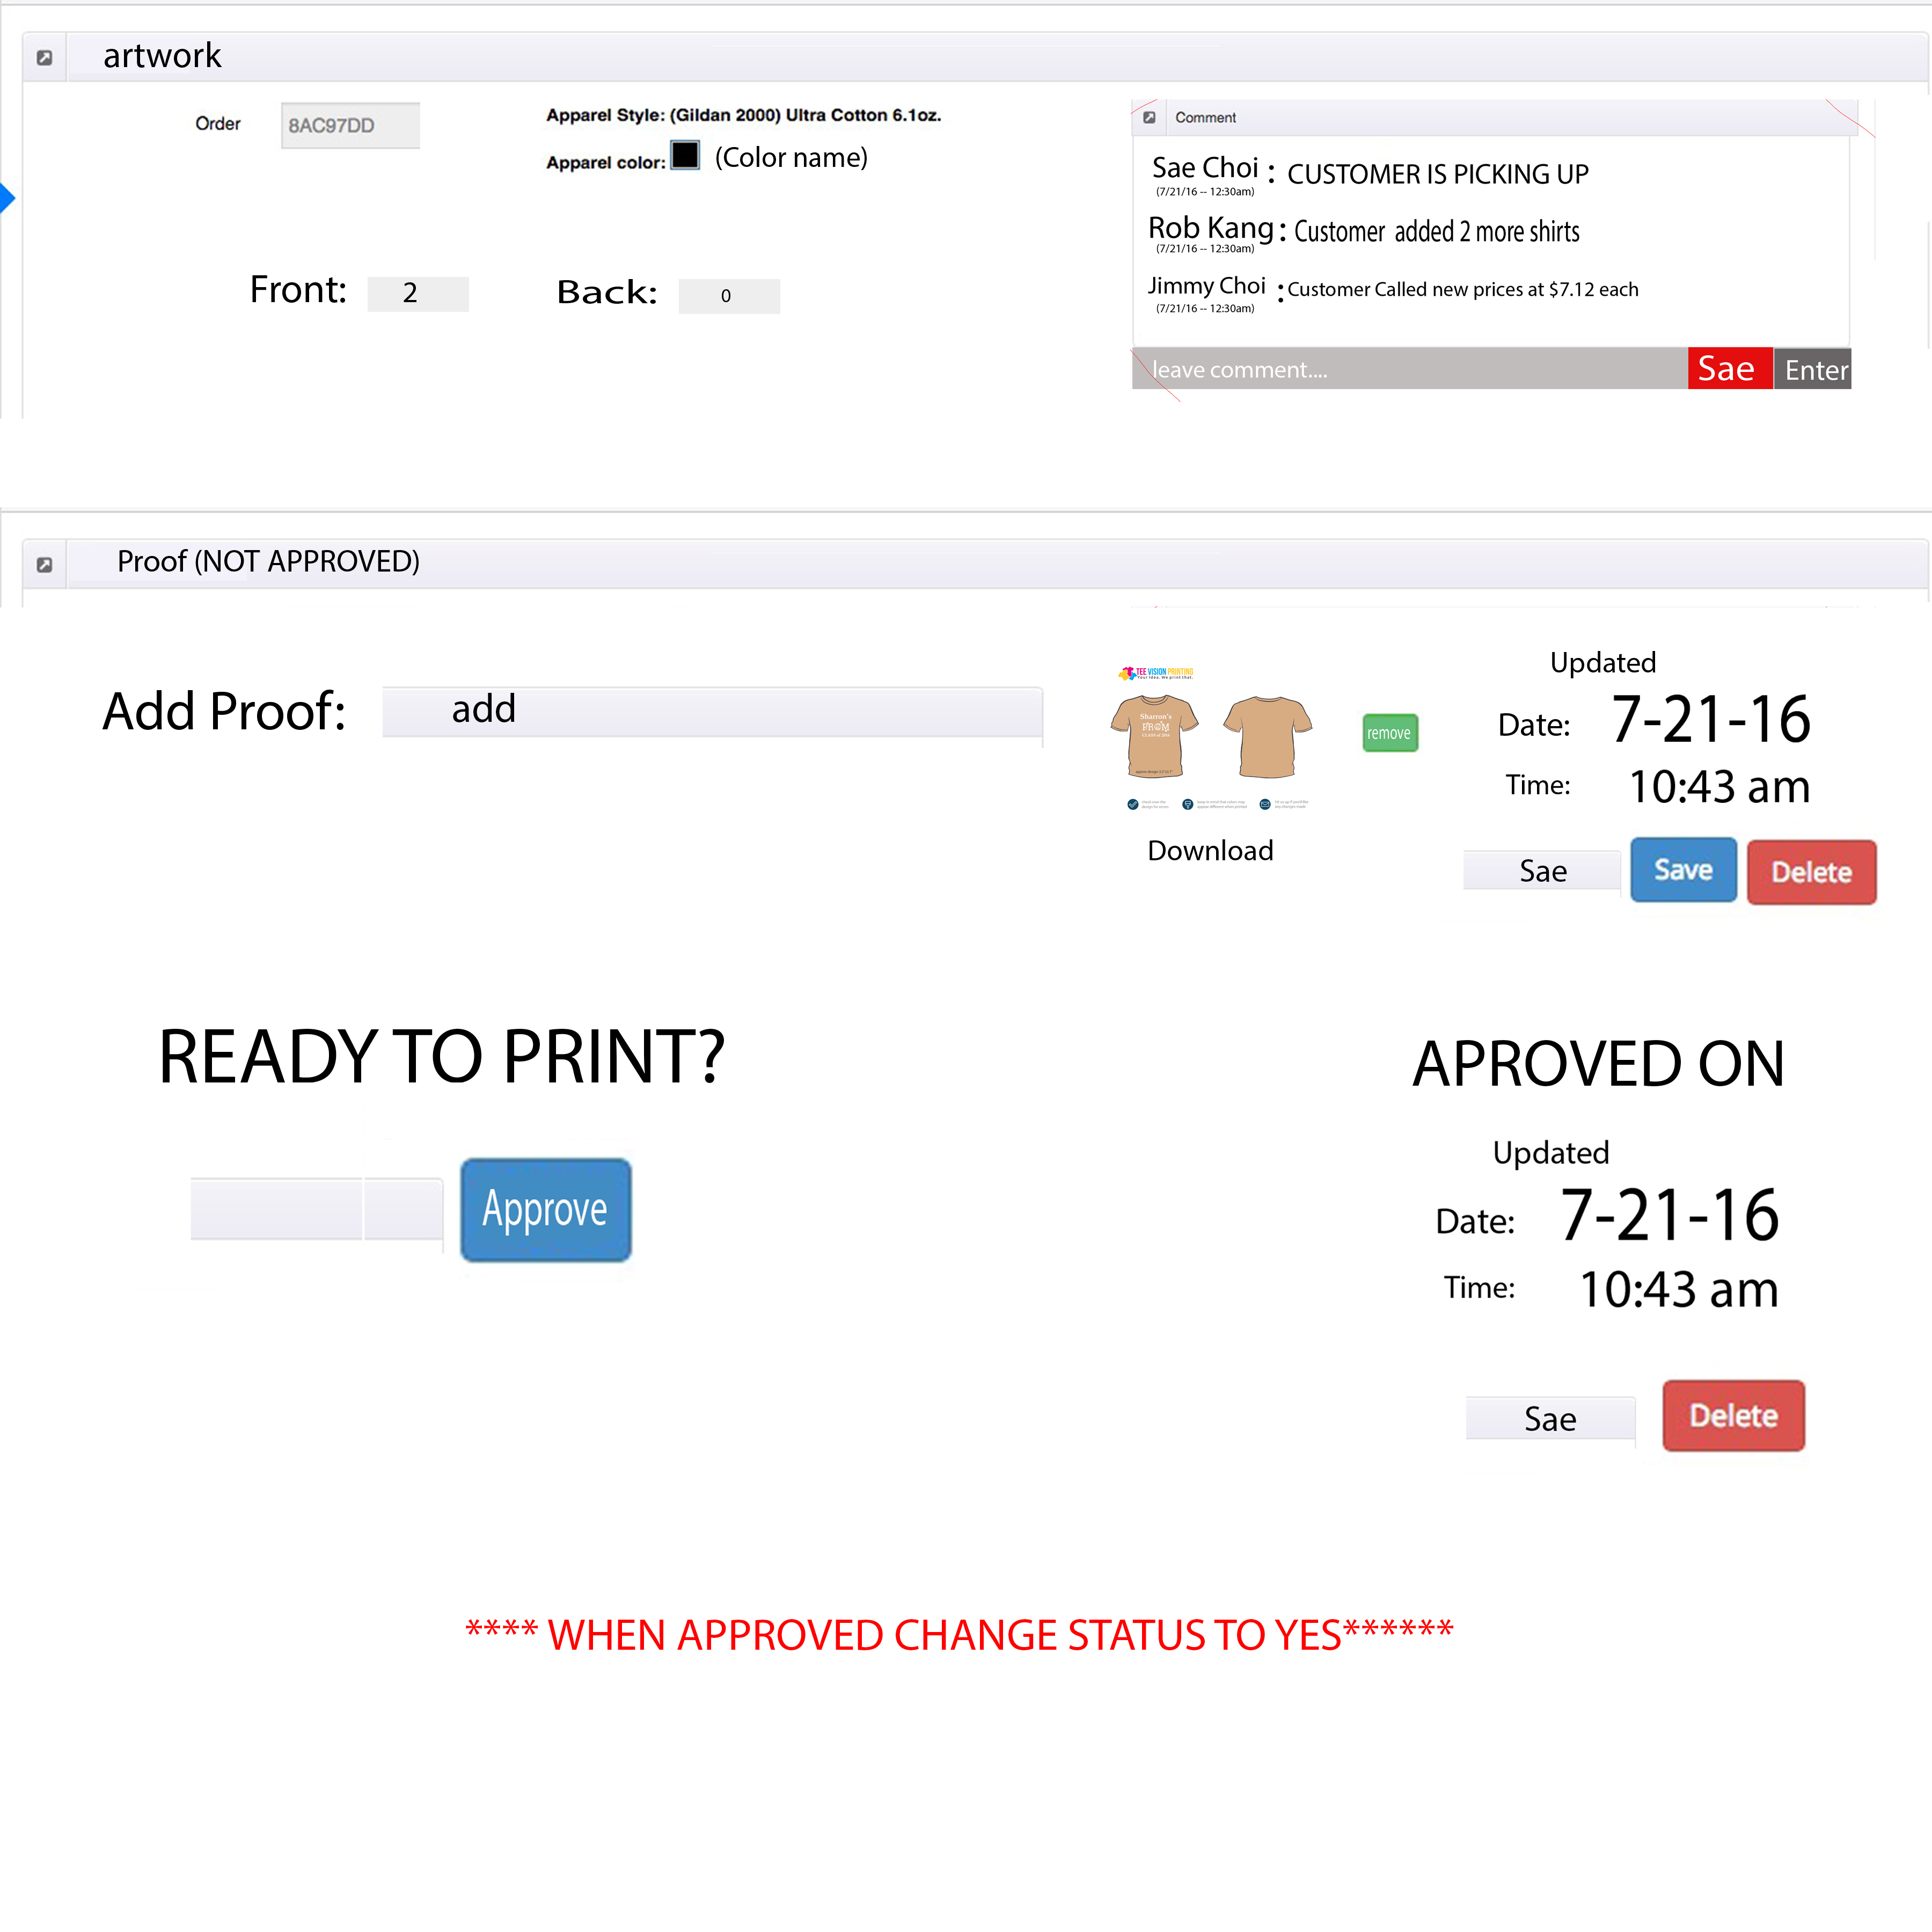

SHIP DATE (THIS IS NEW PAGE)

* Display when click Ship date button? Yes
* How about due date? Please leave Due Date Alone. We do not need to Change

1)---- Have the orginal Date that is set on there.

2) ---- Button for Change ( Change Date will able to change the Date to whatever date)

3)---- Button For Approve ( Approves the Date and makes the Ship Date Color Green.

4)---- When admin approves Name of user must be filled so we know who approved it.

* Can we use the login name to automaticaly add to? Yes

5)----- When date is approved; A Date and Time is shown .

* How about due date? (Please leave Due Date Alone. We do not need to Change)

6)----- Comment Box (Notes) needs to be made so users can “Chat” with each other.

7) Add Address and zip code of users onto this page

* Address and zip code input manualy or get form order shiping information?
* Yes
* (number 4) Do we need show this information in this page? No we do not but We do need to see the Due date and ship date and Order Date. So mostly likely its better to keep in there?

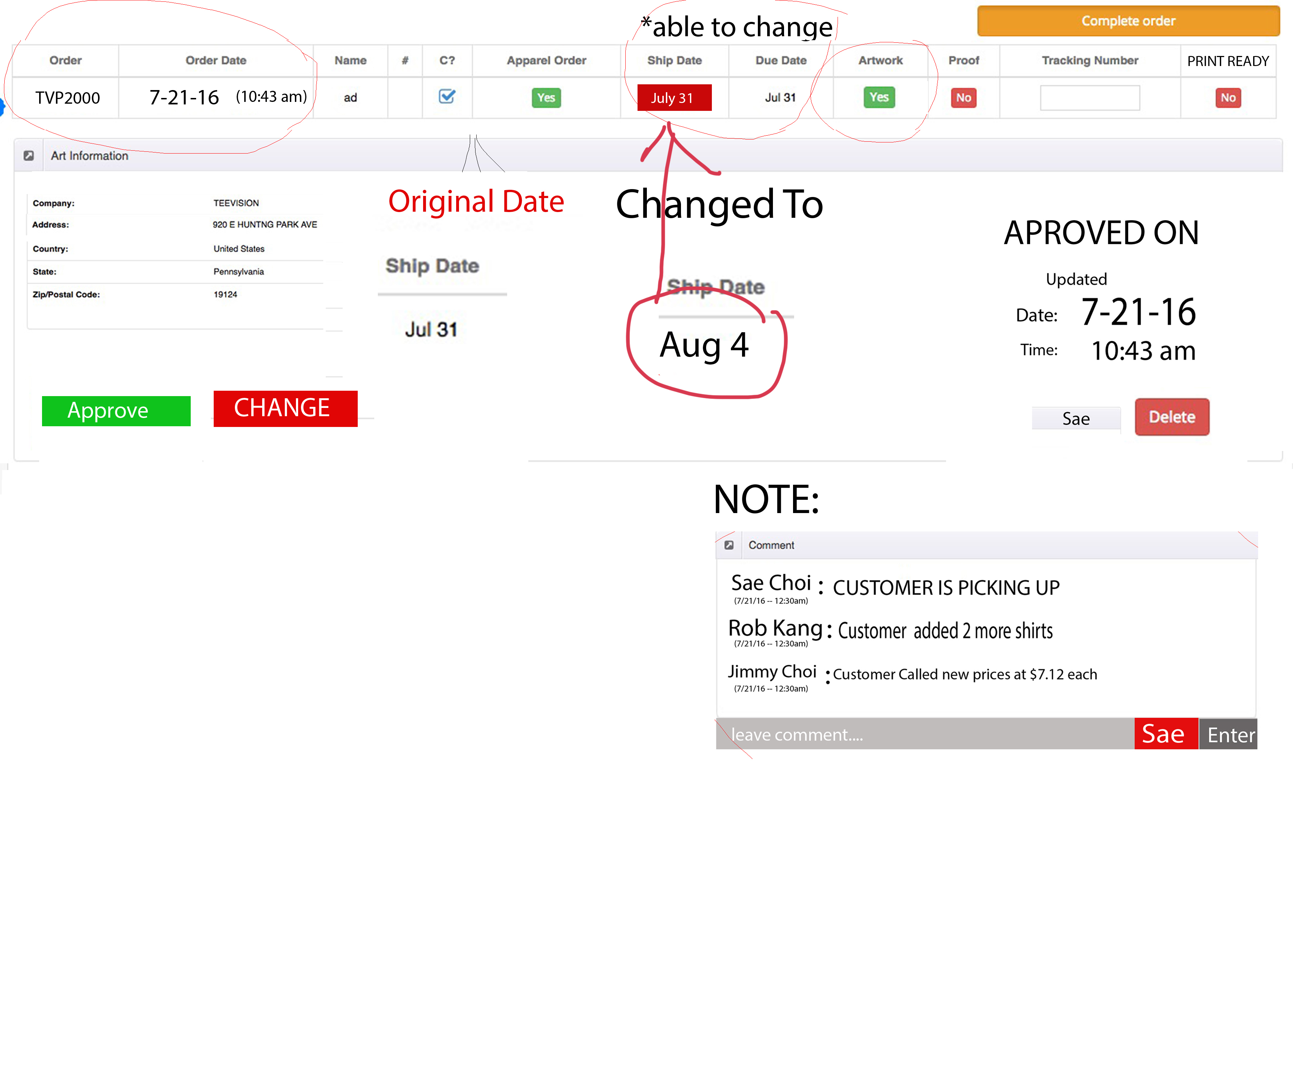

**4**

Ready to Print (THIS IS NEW PAGE)

I not clearly understand this page. Could you please explain more it,

* When click print ready -> will show this page? Yes, but when we click it it gives option to print out in paper those 2 pages (proof image, and order detail but not from main page)
* I don’t understand page 1 and page 2 meaning.

1. Only when all green buttons (apparel, ship date, artwork, proof) Print ready can be changed to green.

This page is the main order detail or new page with only bellow information? Not Main order page. Just New Page with final information

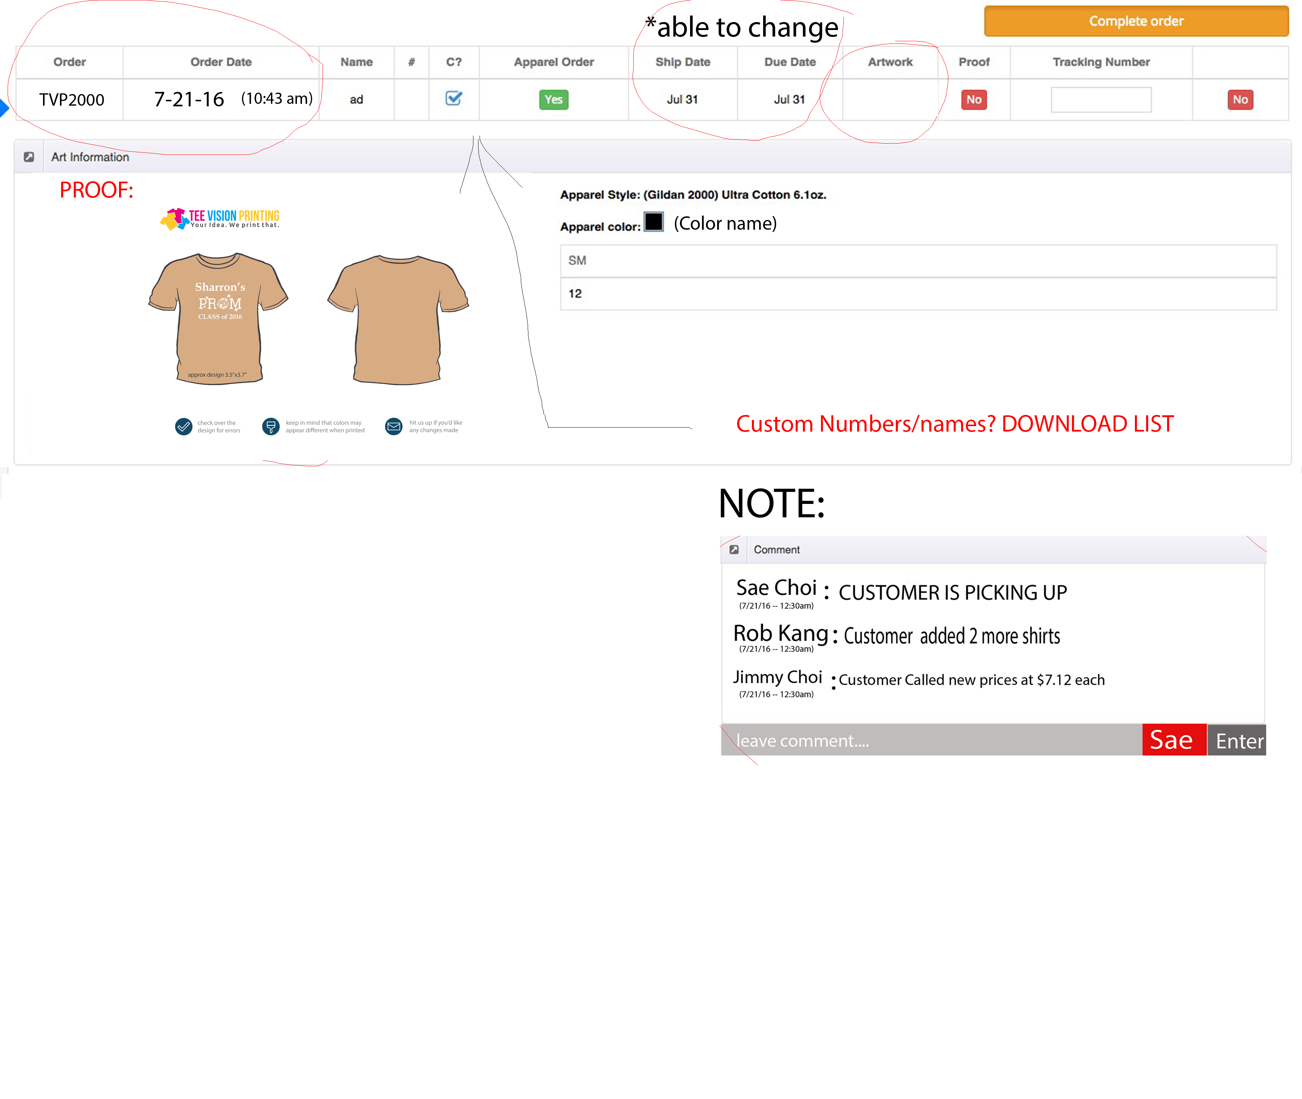

Print Out

* Clicking this button allows to print PROOF
* What button?

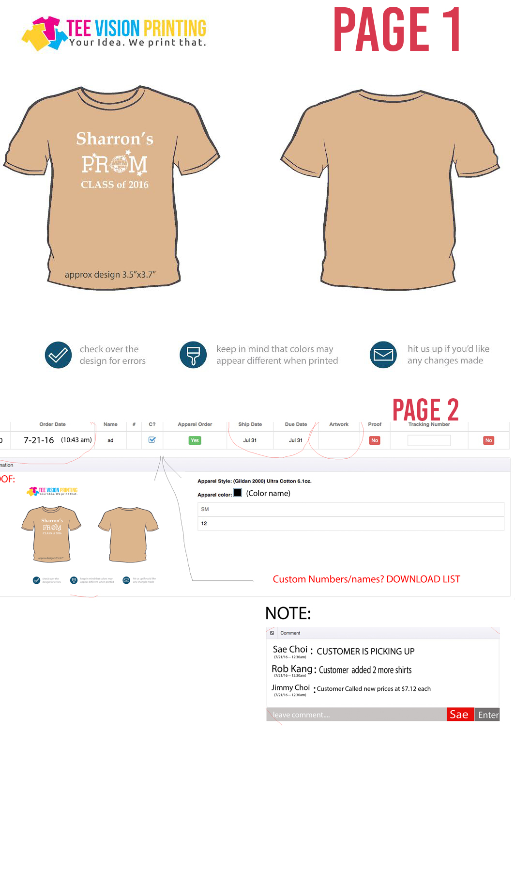

LAST THING --- COUPON DISCOUNT CODES

Able to create on Code number and not generate random numbers. No minimum total.

* We will develop this function?
* Yes, Right now when I want to make a coupon it generates code by itself. But if I want to make code by itself.
* For example Code name is “Sae Choi” and the code is “Sae20” to give 20% off